Assignment-Ⅱ

Fertilizer recommendation system for disease prediction

| Date | 13 October |
| --- | --- |
| Student name | Manju.M |
| Student roll number | **211519106081** |
| Maximum marks | 2 marks |

import pandas as pd import seaborn as sns

import matplotlib.pyplot as plt import numpy as np sns.set_style('darkgrid') sns.set(font_scale=1.3)

df=pd.read_csv("/content/drive/MyDrive/IBM/Assignment - 2

/Churn_Modelling.csv") df.head()

RowNumber CustomerId Surname CreditScore Geography Gender Age \

1. 1 15634602 Hargrave 619 France Female 42
2. 2 15647311 Hill 608 Spain Female 41
3. 3 15619304 Onio 502 France Female 42
4. 4 15701354 Boni 699 France Female 39
5. 5 15737888 Mitchell 850 Spain Female 43

Tenure Balance NumOfProducts HasCrCard IsActiveMember \ 0 2 0.00 1 1 1

1 1 83807.86 1 0 1

2 8 159660.80 3 1 0

3 1 0.00 2 0 0

4 2 125510.82 1 1 1

EstimatedSalary Exited 0 101348.88 1

| 1 | 112542.58 | 0 |
| --- | --- | --- |
| 2 | 113931.57 | 1 |
| 3 | 93826.63 | 0 |
| 4 | 79084.10 | 0 |

df.drop(["RowNumber","CustomerId","Surname"],axis=1,inplace=True) df.info()

<class 'pandas.core.frame.DataFrame'> RangeIndex: 10000 entries, 0 to 9999 Data columns (total 11 columns):

# Column Non-Null Count Dtype

* 1. CreditScore 10000 non-null int64
  2. Geography 10000 non-null object
  3. Gender 10000 non-null object
  4. Age 10000 non-null int64
  5. Tenure 10000 non-null int64
  6. Balance 10000 non-null float64
  7. NumOfProducts 10000 non-null int64
  8. HasCrCard 10000 non-null int64
  9. IsActiveMember 10000 non-null int64
  10. EstimatedSalary 10000 non-null float64
  11. Exited 10000 non-null int64 dtypes: float64(2), int64(7), object(2) memory usage: 859.5+ KB

*#Perform Univariate Analysis* plt.figure(figsize=(8,8)) sns.countplot(x='Tenure',data=df)

plt.xlabel('0:Customers with Bank, 1: exited from bank') plt.ylabel('No.of.Customers')

plt.title("Bank Customers viz") plt.show()

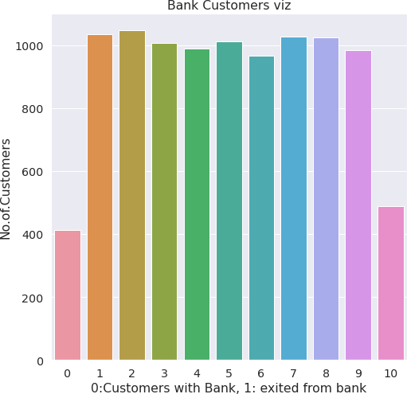

*#Perform Univariate Analysis* plt.figure(figsize=(8,8)) sns.kdeplot(x=df['Balance'])

<matplotlib.axes._subplots.AxesSubplot at 0x7fa0c03906d0>

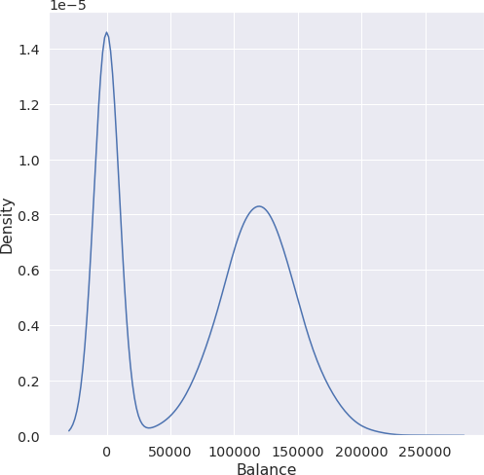

*#Perform Bivariate Analysis*

plt.scatter(df.Age,df.Balance)

<matplotlib.collections.PathCollection at 0x7fa0d35a7dd0>

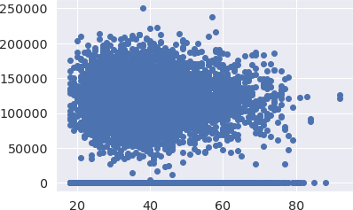

*#Perform Bivariate Analysis*

df.corr()

|  | CreditScore | Gender | | Age | | Tenure | Balance | \ | |
| --- | --- | --- | --- | --- | --- | --- | --- | --- | --- |
| CreditScore | 1.000000 | 0.007888 | | -0.003965 | | 0.000842 | 0.006268 |  | |
| Gender | 0.007888 | 1.000000 | | 0.022812 | | 0.003739 | 0.069408 |  | |
| Age | -0.003965 | 0.022812 | | 1.000000 | | -0.009997 | 0.028308 |  | |
| Tenure | 0.000842 | 0.003739 | | -0.009997 | | 1.000000 | -0.012254 |  | |
| Balance | 0.006268 | 0.069408 | | 0.028308 | | -0.012254 | 1.000000 |  | |
| NumOfProducts | 0.012238 | 0.003972 | | -0.030680 | | 0.013444 | -0.304180 |  | |
| HasCrCard | -0.005458 | -0.008523 | | -0.011721 | | 0.022583 | -0.014858 |  | |
| IsActiveMember | 0.025651 | 0.006724 | | 0.085472 | | -0.028362 | -0.010084 |  | |
| EstimatedSalary | -0.001384 | -0.001369 | | -0.007201 | | 0.007784 | 0.012797 |  | |
| Exited | -0.027094 | 0.035943 | | 0.285323 | | -0.014001 | 0.118533 |  | |
|  | NumOfProducts | | HasCrCard | | IsActiveMember | | EstimatedSalary | | \ |
| CreditScore | 0.012238 | | -0.005458 | | 0.025651 | | -0.001384 | |  |
| Gender | 0.003972 | | -0.008523 | | 0.006724 | | -0.001369 | |  |
| Age | -0.030680 | | -0.011721 | | 0.085472 | | -0.007201 | |  |
| Tenure | 0.013444 | | 0.022583 | | -0.028362 | | 0.007784 | |  |
| Balance | -0.304180 | | -0.014858 | | -0.010084 | | 0.012797 | |  |
| NumOfProducts | 1.000000 | | 0.003183 | | 0.009612 | | 0.014204 | |  |
| HasCrCard | 0.003183 | | 1.000000 | | -0.011866 | | -0.009933 | |  |
| IsActiveMember | 0.009612 | | -0.011866 | | 1.000000 | | -0.011421 | |  |
| EstimatedSalary | 0.014204 | | -0.009933 | | -0.011421 | | 1.000000 | |  |
| Exited | -0.047820 | | -0.007138 | | -0.156128 | | 0.012097 | |  |

Exited

CreditScore -0.027094

| Gender | 0.035943 |
| --- | --- |
| Age | 0.285323 |
| Tenure | -0.014001 |
| Balance | 0.118533 |
| NumOfProducts | -0.047820 |
| HasCrCard | -0.007138 |
| IsActiveMember | -0.156128 |
| EstimatedSalary | 0.012097 |
| Exited | 1.000000 |

*#Perform Bivariate Analysis*

import statsmodels.api as sm

*#define response variable*

y = df['CreditScore']

*#define explanatory variable*

x = df[['EstimatedSalary']]

*#add constant to predictor variables*

x = sm.add_constant(x)

*#fit linear regression model*

model = sm.OLS(y, x).fit()

*#view model summary*

print(model.summary())

OLS Regression Results

=============================================================================

=

Dep. Variable: CreditScore R-squared:

0.000

Model: OLS Adj. R-squared: - 0.000

Method: Least Squares F-statistic:

0.01916

Date: Sat, 24 Sep 2022 Prob (F-statistic): 0.890

Time: 05:06:19 Log-Likelihood: - 59900.

No. Observations: 10000 AIC:

1.198e+05

Df Residuals: 9998 BIC:

1.198e+05

Df Model: 1

Covariance Type: nonrobust

=============================================================================

======

coef std err t P>|t| [0.025

654.565

|  |  |  |  |  |
| --- | --- | --- | --- | --- |
| 0.975] |  | | | |
| const 650.7617 1.940 | | 335.407 | 0.000 | 646.958 |
| EstimatedSalary-2.326e-06 1.68e-05 | | -0.138 | 0.890 | -3.53e-05 |
| 3.06e-05  =============================================================================  = | | | | |
| Omnibus:2.014  Prob(Omnibus): | 132.939  0.000 | Durbin-Watson:  Jarque-Bera(JB): | |  |
| 84.242  Skew: | -0.072 | Prob(JB): | | 5.10e- |
| 19  Kurtosis: | 2.574 | Cond.No. | |  |
| 2.32e+05 |  |  | |  |
| =============================================================================  = | | | | |

Notes:

1. Standard Errors assume that the covariance matrix of the errors is correctly specified.
2. The condition number is large, 2.32e+05. This might indicate that there are

strong multicollinearity or other numerical problems.

/usr/local/lib/python3.7/dist-packages/statsmodels/tsa/tsatools.py:142: FutureWarning: In a future version of pandas all arguments of concat except for the argument 'objs' will be keyword-only

x = pd.concat(x[::order], 1)

*#Perform Multivariate Analysis*

plt.figure(figsize=(4,4)) sns.pairplot(data=df[["Balance","CreditScore","EstimatedSalary","NumOfProduct s","Tenure","Exited"]],hue="Exited")

<seaborn.axisgrid.PairGrid at 0x7fa0b00a1b10>

<Figure size 288x288 with 0 Axes>

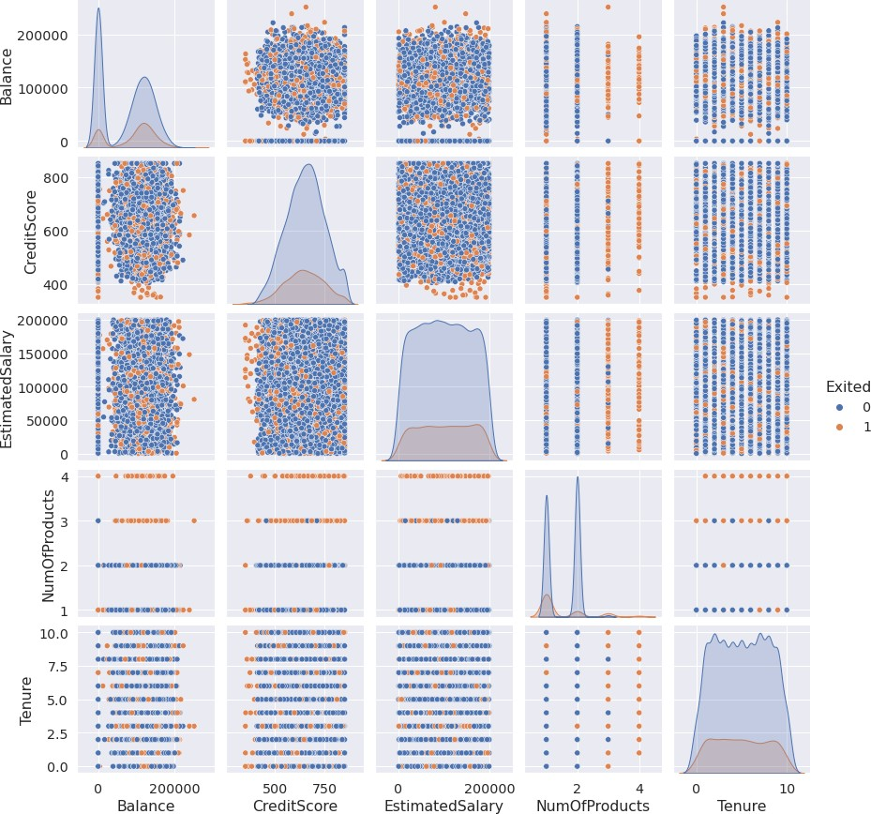

*#Perform Descriptive Statistics* df=pd.DataFrame(df) print(df.sum())

| CreditScore  Geography  Gender | 6505288  FranceSpainFranceFranceSpainSpainFranceGermany...  FemaleFemaleFemaleFemaleFemaleMaleMaleFemaleMa... |
| --- | --- |
| Age | 389218 |
| Tenure | 50128 |
| Balance | 764858892.88 |
| NumOfProducts | 15302 |
| HasCrCard | 7055 |
| IsActiveMember | 5151 |
| EstimatedSalary | 1000902398.81 |
| Exited | 2037 |
| dtype: object |  |

*#Perform Descriptive Statistics*

print("----Sum Value ")

print(df.sum(1))

print(" ") print("-----Product Value ")

print(df.prod())

print(" ")

| ----Sum | Value----- | |
| --- | --- | --- |
| 0 | 102015.88 | |
| 1 | 197002.44 | |
| 2 | 274149.37 | |
| 3 | 94567.63 | |
| 4  9995 | 205492.92  ... 97088.64 | |
| 9996 | 159633.38 | |
| 9997 | 42840.58 | |
| 9998 | 168784.83 | |
| 9999 | 169159.57 | |
| Length: | 10000, dtype: float64 | |
| -----Product | | Value----- |
| CreditScore | | 0.0 |
| Age | | 0.0 |
| Tenure | | 0.0 |
| Balance | | 0.0 |
| NumOfProducts | | 0.0 |
| HasCrCard | | 0.0 |

IsActiveMember 0.0

EstimatedSalary inf Exited 0.0

dtype: float64

/usr/local/lib/python3.7/dist-packages/ipykernel_launcher.py:3: FutureWarning: Dropping of nuisance columns in DataFrame reductions (with 'numeric_only=None') is deprecated; in a future version this will raise TypeError. Select only valid columns before calling the reduction.

This is separate from the ipykernel package so we can avoid doing imports until

/usr/local/lib/python3.7/dist-packages/numpy/core/_methods.py:52:

RuntimeWarning: overflow encountered in reduce

return umr_prod(a, axis, dtype, out, keepdims, initial, where)

/usr/local/lib/python3.7/dist-packages/ipykernel_launcher.py:6: FutureWarning: Dropping of nuisance columns in DataFrame reductions (with 'numeric_only=None') is deprecated; in a future version this will raise TypeError. Select only valid columns before calling the reduction.

*#Perform Descriptive Statistics*

print(" Mean Value ")

print(df.mean())

print(" ") print("----------Median Value ")

print(df.median())

print(" ") print(" Mode Value ") print(df.mode())

print(" ")

Mean Value CreditScore 650.528800

Age 38.921800

Tenure 5.012800

Balance 76485.889288

NumOfProducts 1.530200

HasCrCard 0.705500

IsActiveMember 0.515100

EstimatedSalary 100090.239881

Exited 0.203700

dtype: float64

Median Value CreditScore 652.000

Age 37.000

Tenure 5.000

Balance 97198.540

NumOfProducts 1.000

HasCrCard 1.000

IsActiveMember 1.000

EstimatedSalary 100193.915

Exited 0.000

dtype: float64

Mode Value

CreditScore Geography Gender Age Tenure Balance NumOfProducts \ 0 850 France Male 37 2 0.0 1

HasCrCard IsActiveMember EstimatedSalary Exited 0 1 1 24924.92 0

/usr/local/lib/python3.7/dist-packages/ipykernel_launcher.py:3: FutureWarning: Dropping of nuisance columns in DataFrame reductions (with 'numeric_only=None') is deprecated; in a future version this will raise TypeError. Select only valid columns before calling the reduction.

This is separate from the ipykernel package so we can avoid doing imports until

/usr/local/lib/python3.7/dist-packages/ipykernel_launcher.py:6: FutureWarning: Dropping of nuisance columns in DataFrame reductions (with 'numeric_only=None') is deprecated; in a future version this will raise

TypeError. Select only valid columns before calling the reduction.

*#Handling with missing Values*

df.isnull()*#Checking values are null*

| \ | CreditScore | Geography | Gender | | Age | Tenure | | Balance | NumOfProducts |
| --- | --- | --- | --- | --- | --- | --- | --- | --- | --- |
| 0 | False | False | False | | False | False | | False | False |
| 1 | False | False | False | | False | False | | False | False |
| 2 | False | False | False | | False | False | | False | False |
| 3 | False | False | False | | False | False | | False | False |
| 4 | False | False | False | | False | False | | False | False |
| ... | ... | ... | ... | | ... | ... | | ... | ... |
| 9995 | False | False | False | | False | False | | False | False |
| 9996 | False | False | False | | False | False | | False | False |
| 9997 | False | False | False | | False | False | | False | False |
| 9998 | False | False | False | | False | False | | False | False |
| 9999 | False | False | False | | False | False | | False | False |
|  | HasCrCard | IsActiveMember | | EstimatedSalary | | | Exited | | |
| 0 | False | False | | False | | | False | | |
| 1 | False | False | | False | | | False | | |
| 2 | False | False | | False | | | False | | |
| 3 | False | False | | False | | | False | | |
| 4 | False | False | | False | | | False | | |
| ... | ... | ... | | ... | | | ... | | |
| 9995 | False | False | | False | | | False | | |
| 9996 | False | False | | False | | | False | | |
| 9997 | False | False | | False | | | False | | |
| 9998 | False | False | | False | | | False | | |
| 9999 | False | False | | False | | | False | | |

[10000 rows x 11 columns]

*#Handling with missing Values*

df.notnull()*#Checking values are not null*

|  | CreditScore | Geography | Gender | Age | Tenure | Balance | NumOfProducts | \ |
| --- | --- | --- | --- | --- | --- | --- | --- | --- |
| 0 | True | True | True | True | True | True | True |  |
| 1 | True | True | True | True | True | True | True |  |
| 2 | True | True | True | True | True | True | True |  |
| 3 | True | True | True | True | True | True | True |  |
| 4 | True | True | True | True | True | True | True |  |
| ... | ... | ... | ... | ... | ... | ... | ... |  |
| 9995 | True | True | True | True | True | True | True |  |
| 9996 | True | True | True | True | True | True | True |  |
| 9997 | True | True | True | True | True | True | True |  |
| 9998 | True | True | True | True | True | True | True |  |
| 9999 | True | True | True | True | True | True | True |  |

|  | HasCrCard | IsActiveMember | EstimatedSalary | Exited |
| --- | --- | --- | --- | --- |
| 0 | True | True | True | True |
| 1 | True | True | True | True |
| 2 | True | True | True | True |
| 3 | True | True | True | True |
| 4 | True | True | True | True |
| ... | ... | ... | ... | ... |
| 9995 | True | True | True | True |
| 9996 | True | True | True | True |
| 9997 | True | True | True | True |
| 9998 | True | True | True | True |
| 9999 | True | True | True | True |

[10000 rows x 11 columns]

*#Find outliers & replace the outliers*

sns.boxplot(df['Balance'])

/usr/local/lib/python3.7/dist-packages/seaborn/_decorators.py:43: FutureWarning: Pass the following variable as a keyword arg: x. From version 0.12, the only valid positional argument will be `data`, and passing other arguments without an explicit keyword will result in an error or misinterpretation.

FutureWarning

<matplotlib.axes._subplots.AxesSubplot at 0x7fa0af6dcf90>

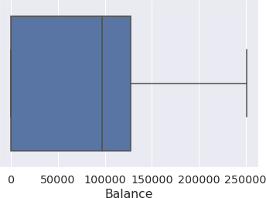

*#Find outliers & replace the outliers*

print(np.where(df['Balance']>100000))

(array([ 2, 4, 5, ..., 9987, 9993, 9999]),)

*#Find outliers & replace the outliers*

from scipy import stats import numpy as np

z = np.abs(stats.zscore(df["EstimatedSalary"])) print(z)

| 0 | 0.021886 |
| --- | --- |
| 1 | 0.216534 |
| 2 | 0.240687 |
| 3 | 0.108918 |
| 4 | 0.365276 |
|  | ... |
| 9995 | 0.066419 |
| 9996 | 0.027988 |
| 9997 | 1.008643 |
| 9998 | 0.125231 |
| 9999 | 1.076370 |
| Name: | EstimatedSalary, Length: 10000, dtype: float64 |

*#Check for categorical columns & performs encoding* from sklearn.preprocessing import LabelEncoder df['Gender'].unique()

array(['Female', 'Male'], dtype=object)

*#Check for categorical columns & performs encoding*

df['Gender'].value_counts()

Male 5457

Female 4543

Name: Gender, dtype: int64

*#Check for categorical columns & performs encoding* encoding=LabelEncoder() df["Gender"]=encoding.fit_transform(df.iloc[:,1].values) df

|  | CreditScore | Geography | Gender | Age | Tenure | Balance | NumOfProducts | \ |
| --- | --- | --- | --- | --- | --- | --- | --- | --- |
| 0 | 619 | France | 0 | 42 | 2 | 0.00 | 1 |  |
| 1 | 608 | Spain | 2 | 41 | 1 | 83807.86 | 1 |  |
| 2 | 502 | France | 0 | 42 | 8 | 159660.80 | 3 |  |
| 3 | 699 | France | 0 | 39 | 1 | 0.00 | 2 |  |
| 4 | 850 | Spain | 2 | 43 | 2 | 125510.82 | 1 |  |
| ... | ... | ... | ... | ... | ... | ... | ... |  |
| 9995 | 771 | France | 0 | 39 | 5 | 0.00 | 2 |  |
| 9996 | 516 | France | 0 | 35 | 10 | 57369.61 | 1 |  |

| 9997 | 709 | France | 0 | 36 | 7 | 0.00 | 1 |
| --- | --- | --- | --- | --- | --- | --- | --- |
| 9998 | 772 | Germany | 1 | 42 | 3 | 75075.31 | 2 |
| 9999 | 792 | France | 0 | 28 | 4 | 130142.79 | 1 |
|  | HasCrCard | IsActiveMember | EstimatedSalary | | | Exited | |
| 0 | 1 | 1 | 101348.88 | | | 1 | |
| 1 | 0 | 1 | 112542.58 | | | 0 | |
| 2 | 1 | 0 | 113931.57 | | | 1 | |
| 3 | 0 | 0 | 93826.63 | | | 0 | |
| 4 | 1 | 1 | 79084.10 | | | 0 | |
| ... | ... | ... | ... | | | ... | |
| 9995 | 1 | 0 | 96270.64 | | | 0 | |
| 9996 | 1 | 1 | 101699.77 | | | 0 | |
| 9997 | 0 | 1 | 42085.58 | | | 1 | |
| 9998 | 1 | 0 | 92888.52 | | | 1 | |
| 9999 | 1 | 0 | 38190.78 | | | 0 | |

[10000 rows x 11 columns]

*#Check for categorical columns & performs encoding #Split the data into Dependent & Independent Variables*

print("----------Dependent Variables ")

X=df.iloc[:,1:4] print(X)

print(" ") print("---------Independent Variables ")

Y=df.iloc[:,4] print(Y)

print(" ")

Dependent Variables

|  |  |  |  |  |
| --- | --- | --- | --- | --- |
|  | Age | Tenure | Balance |  |
| 0 | 42 | 2 | 0.00 |  |
| 1 | 41 | 1 | 83807.86 |  |
| 2 | 42 | 8 | 159660.80 |  |
| 3 | 39 | 1 | 0.00 |  |
| 4 | 43 | 2 | 125510.82 |  |
| ... | ... | ... | ... |  |
| 9995 | 39 | 5 | 0.00 |  |
| 9996 | 35 | 10 | 57369.61 |  |
| 9997 | 36 | 7 | 0.00 |  |
| 9998 | 42 | 3 | 75075.31 |  |
| 9999 | 28 | 4 | 130142.79 |  |

[10000 rows x 3 columns]

---------Independent Variables---------

0 1

1 1

| 2 | 3 |
| --- | --- |
| 3 | 2 |
| 4 | 1 |
|  | .. |
| 9995 | 2 |
| 9996 | 1 |
| 9997 | 1 |
| 9998 | 2 |
| 9999 | 1 |
| Name: | NumOfProducts, Length: 10000, dtype: int64 |

*#Scale the independent Variables*

from sklearn.preprocessing import StandardScaler object= StandardScaler()

*# standardization*

scale = object.fit_transform(df) print(scale)

| [[-0.32622142 | | 0.29351742 | -1.04175968 | ... | 0.97024255 | 0.02188649 |
| --- | --- | --- | --- | --- | --- | --- |
| 1.97716468] | |  |  |  |  |  |
| [-0.44003595 | | 0.19816383 | -1.38753759 | ... | 0.97024255 | 0.21653375 |
| -0.50577476] | |  |  |  |  |  |
| [-1.53679418 | | 0.29351742 | 1.03290776 | ... | -1.03067011 | 0.2406869 |
| 1.97716468] | |  |  |  |  |  |
| ... | |  |  |  |  |  |
| [ | 0.60498839 -0.27860412 | | 0.68712986 ... 0.97024255 | | | -1.00864308 |
|  | 1.97716468] | |  | | |  |
| [ | 1.25683526 0.29351742 | | -0.69598177 ... -1.03067011 | | | -0.12523071 |
|  | 1.97716468] | |  | | |  |
| [ | 1.46377078 -1.04143285 | | -0.35020386 ... -1.03067011 | | | -1.07636976 |

-0.50577476]]

*#Split the data into training & testing*

from sklearn.model_selection import train_test_split

*#Split the data into training & testing*

x_train, x_test, y_train, y_test = train_test_split(x, y, test_size=4,random_state=4)

x_train

|  | const | EstimatedSalary |
| --- | --- | --- |
| 2558 | 1.0 | 137903.54 |
| 7642 | 1.0 | 121765.00 |
| 8912 | 1.0 | 109470.34 |
| 3319 | 1.0 | 2923.61 |
| 6852 | 1.0 | 7312.25 |
| ... | ... | ... |
| 456 | 1.0 | 7666.73 |
| 6017 | 1.0 | 9085.00 |
| 709 | 1.0 | 147794.63 |

| 8366 | 1.0 | 102515.42 |
| --- | --- | --- |
| 1146 | 1.0 | 54776.64 |

[9996 rows x 2 columns]

*#Split the data into training & testing*

x_test

|  | const | EstimatedSalary |
| --- | --- | --- |
| 1603 | 1.0 | 23305.85 |
| 8713 | 1.0 | 41248.80 |
| 4561 | 1.0 | 143317.42 |
| 6600 | 1.0 | 174123.16 |

*#Split the data into training & testing*

y_train

|  |  |
| --- | --- |
| 2558 | 727 |
| 7642 | 811 |
| 8912 | 623 |
| 3319 | 430 |
| 6852 | 600 |
| 456 | ...  733 |
| 6017 | 487 |
| 709 | 686 |
| 8366 | 637 |
| 1146 | 614 |
| Name: | CreditScore,Length:9996,dtype: |
| *#Split*  y_test | *thedataintotraining&testing* |
| 1603 | 576 |
| 8713 | 786 |
| 4561 | 562 |
| 6600 | 505 |
| Name: | CreditScore,dtype:int64 |

int64